Project Documentation

|  |  |
| --- | --- |
| Team ID | PNT2022TMID25916 |
| Project Name | VirtualEye-Lifeguard for Swimming Pools to Detect the Active Drowning |

1. **INTRODUCTION** 
   1. Project Overview
   2. Purpose
2. **LITERATURE SURVEY**
   1. Existing problem
   2. References
   3. Problem Statement Definition
3. **IDEATION & PROPOSED SOLUTION**
   1. Empathy Map Canvas
   2. Ideation & Brainstorming
   3. Proposed Solution
   4. Problem Solution fit
4. **REQUIREMENT ANALYSIS**
   1. Functional requirement
   2. Non-Functional requirements
5. **PROJECT DESIGN**
   1. Data Flow Diagrams
   2. Solution & Technical Architecture
   3. User Stories

1. **PROJECT PLANNING & SCHEDULING**
   1. Sprint Planning & Estimation
   2. Sprint Delivery Schedule
   3. Reports from JIRA

1. **CODING & SOLUTIONING** 
   1. Feature 1
   2. Feature 2
   3. Database Schema (if Applicable)

1. **TESTING** 
   1. Test Cases
   2. User Acceptance Testing

1. **RESULTS**
   1. Performance Metrics

1. **ADVANTAGES & DISADVANTAGES**

1. **CONCLUSION**

1. **FUTURE SCOPE**

1. **APPENDIX**

Source Code

GitHub & Project Demo Link

1. **INTRODUCTION:**
   1. Project Overview

                 Safety in swimming pools is a critical issue. In this a real time drowning detection method, using HSV color space analysis is presented ,which uses prior knowledge of the video sequence to set the best value for color channels.

* 1. Purpose:
* To monitor the swimming pool in real-time through the camera installed above the water surface in a real public swimming place.
* Gives an alarm, with an alert message to notify that the swimmer is in a cautious situation drowning inside the swimming pool.

1. **LITERATURE SURVEY**:
   1. **Existing problem**:

One important environment that the need for monitoring systems is crucially sensed is the swimming pool. Each year many people including children are drowned or very close to drowning in the deeps of the swimming pools, and the life guards are not trained well enough to handle these problems. This raises the need for having a system that will automatically detect the drowning person and alarm the lifeguards of such danger. Real-time detection of a drowning person in swimming pools is a challenging task that requires an accurate system. The challenge is due to the presence of water ripples, shadows and splashes and therefore detection needs to have high accuracy.

* 1. **References:**

[1] Foresti, Gian Luca, Petri Mähönen, and Carlo S. Regazzoni, eds. Multimedia video-based surveillance systems: Requirements, Issues and Solutions. Vol. 573. Springer Science & Business Media, 2012.

[2] Jones, Graeme A., Nikos Paragios, and Carlo S. Regazzoni, eds. Video-based surveillance systems: computer vision and distributed processing. Springer Science & Business Media, 2012.

[3] Conde, Cristina, et al. "HoGG: Gabor and HoG-based human detection for surveillance in non-controlled environments." Neurocomputing 100 (2013): 19-30.

[4] Wang, Xiaogang. "Intelligent multi-camera video surveillance: A review." Pattern recognition letters 34.1 (2013): 3-19.

[5] Gudyś, Adam, et al. "Tracking people in video sequences by clustering feature motion paths." Computer Vision and Graphics. Springer International Publishing, 2014. 236-245.

[6] Vezzani, Roberto, Davide Baltieri, and Rita Cucchiara. "People reidentification in surveillance and forensics: A survey." ACM Computing Surveys (CSUR) 46.2 (2013): 29

* 1. **Problem statement definition:**

Problem statement definitions can be made respectively , in several problems, as given below:



1. **IDEATION & PROPOSED SOLUTION**:
   1. **Empathy map canvas:**

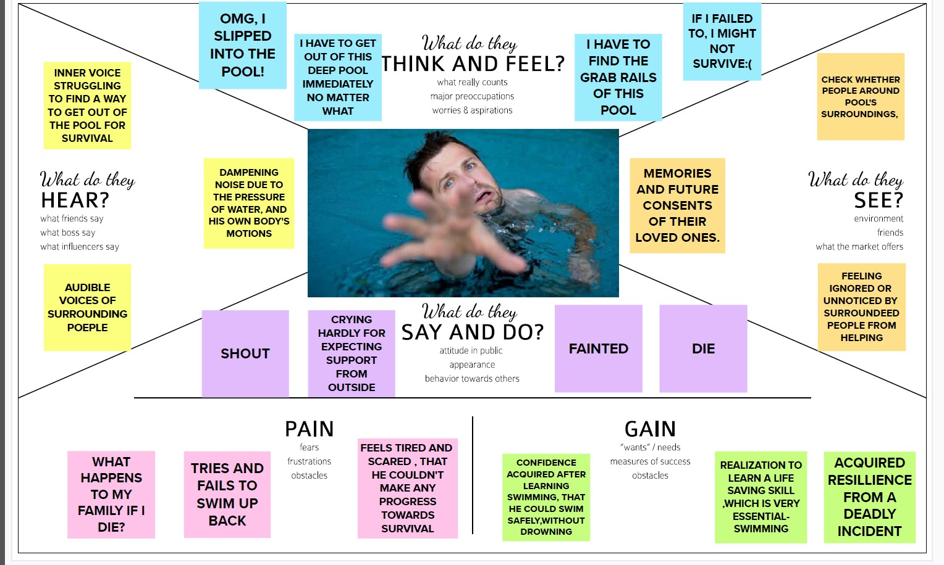

* 1. **Ideation and Brainstorming:**

**Problem Statement:** Safety in swimming pools is a critical issue. In this a real time drowning detection method, using HSV color space analysis is presented ,which uses prior knowledge of the video sequence to set the best value for color channels.

**Big Idea:**

1. Time decrement
2. Ejection fraction for earlier predict
3. Pulse rate detection
4. Send notification to control monitor as well.
   1. **Proposed Statement:**

|  |
| --- |
| **Problem Statement :** |

|  |
| --- |
| Drowning detection system that detects every dangerous situation and accident. This software works in close integration with the cameras installed in the pool to continuously scan the pool. |

**Idea / Solution description:**

This system by analyzing the movement and shape, evaluates swimmers’ condition based on visual based monitoring device and an alarm to alert the lifeguards and provides solution in detecting drowning incidents.

While challenging in many aspects, a successful system will bring inestimable value in saving human lives.

**Scalability of the Solution:**

Our proposed solution is very scalable i.e., in future ,there are a lot of rooms for evolving our present model by Adding new features to enhance our system in the future.

* 1. **Problem solution fit**:

Below figure depicts the problem solution fit of our problem

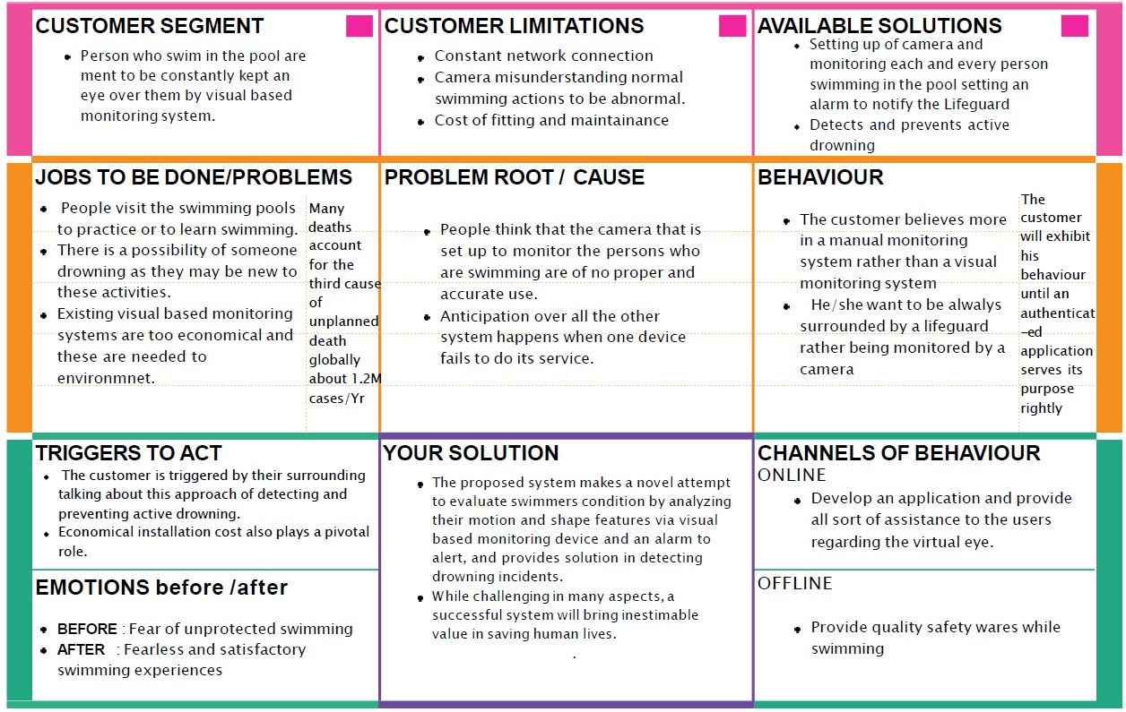

1. **Requirement Analysis:**
   1. **Functional Requirements:**

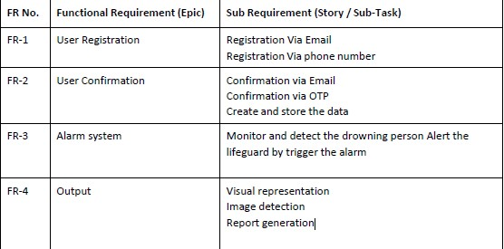

* 1. **Non- functional Requirements:**

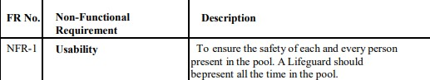

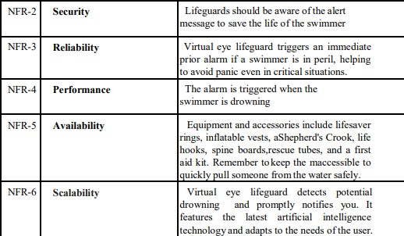

1. **Project Design:**
   1. **Data Flow Diagram:**

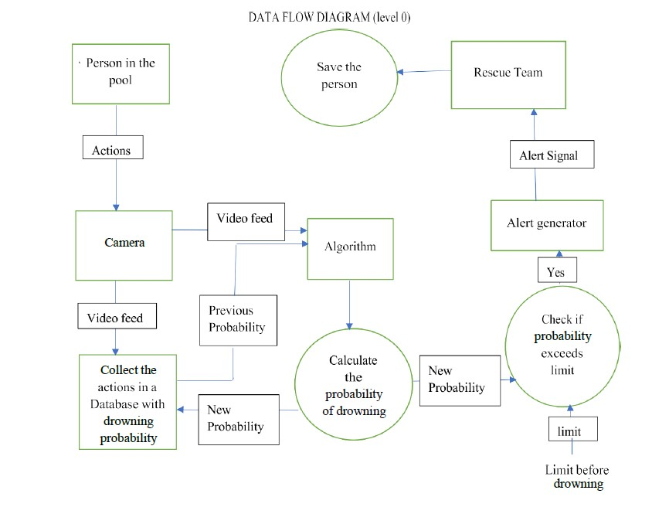

* 1. **Solution & Technical Architecture:**

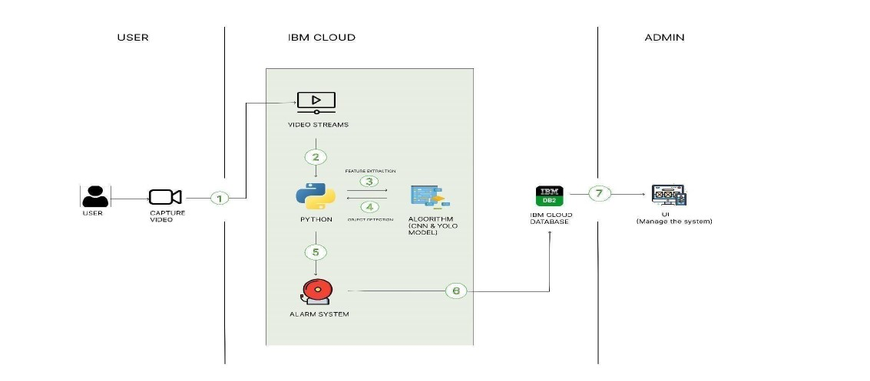

* 1. **User Stories:**

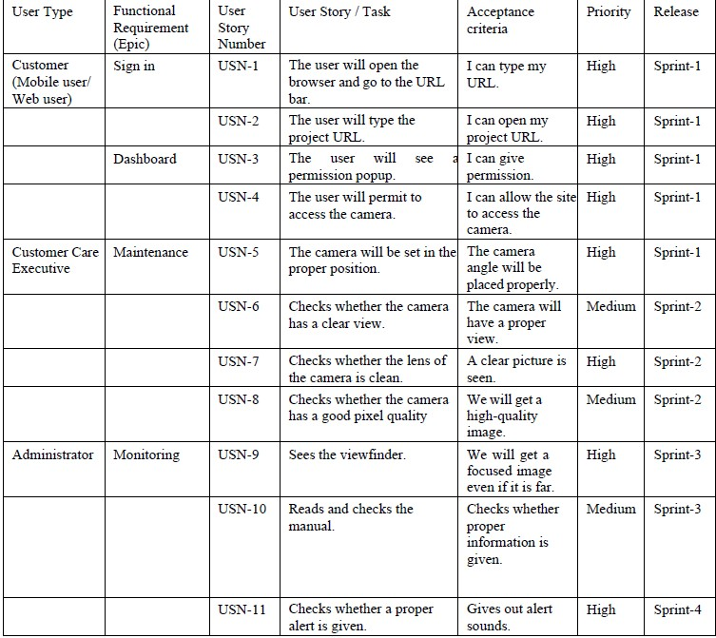

1. **PROJECT PLANNING & SCHEDULING:**
   1. **Sprint Planning & Estimation**

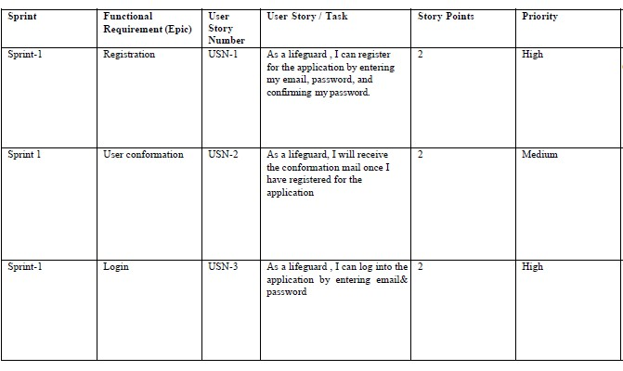

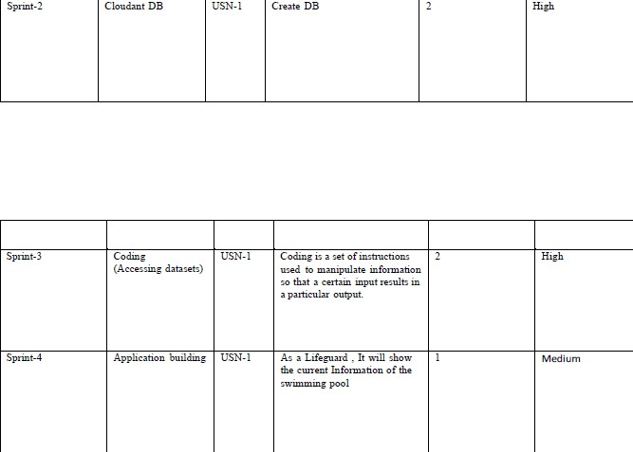

* 1. **Sprint Delivery Schedule:**

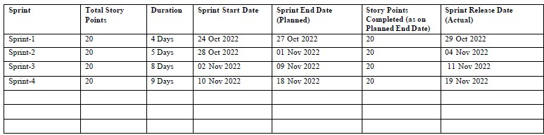

* 1. **Reports from JIRA:**

**Burnup Report:**

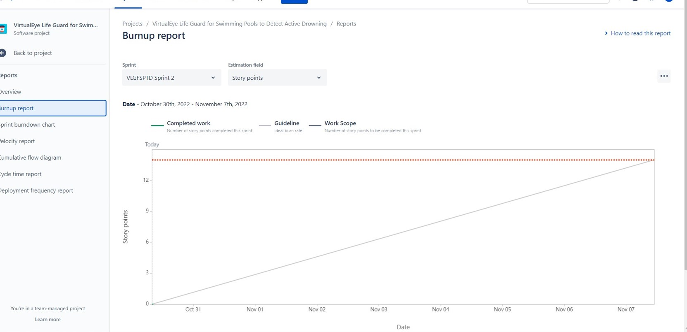

**Velocity Report:**

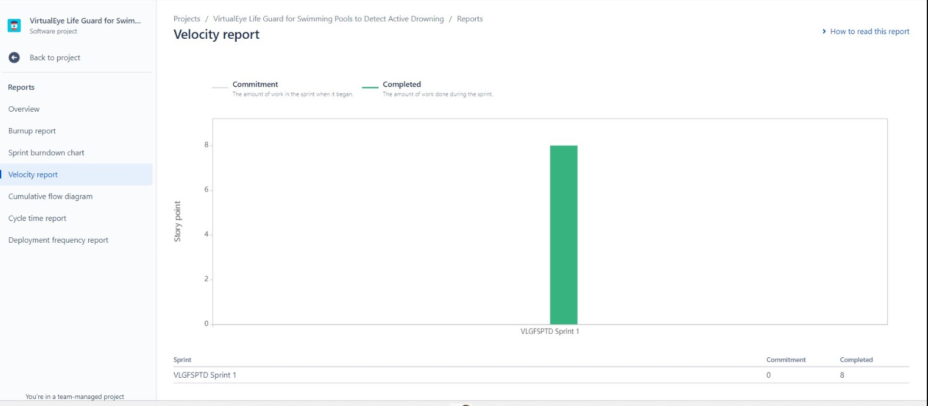

1. **CODING & SOLUTIONING:**
   1. **Feature 1:**

We use HTML & CSS for creating a front end web page for our application, to register a user, and then letting the user to login . The script goes as below,

**Login.html**

<!DOCTYPE html>

<html lang="en">

<head>

<meta charset="utf-8">

<meta name="author" content="templatemo">

<meta name="viewport" content="width=device-width, initial-scale=1, shrink-to-fit=no">

<link href="https://fonts.googleapis.com/css2?family=Roboto:wght@100;300;400;500;700;900&displa y=swap" rel="stylesheet">

<title>Drowning Detection</title>

<!-- Bootstrap core CSS -->

<link type="text/css" rel="stylesheet" href="{{ url_for('static', filename='bootstrap/css/bootstrap.min.css') }}" />

<link type="text/css" rel="stylesheet" href="{{ url_for('static', filename='css/bootstrap.min.css')

}}" />

<link type="text/css" rel="stylesheet" href="{{ url_for('static', filename='css/style1.css') }}" />

<link type="text/css" rel="stylesheet" href="{{ url_for('static', filename='css/fontawesome.css')

}}" />

<link type="text/css" rel="stylesheet" href="{{ url_for('static', filename='css/templatemo-liberty- market.css') }}" />

<link type="text/css" rel="stylesheet" href="{{ url_for('static', filename='css/owl.css') }}" />

<link type="text/css" rel="stylesheet" href="{{ url_for('static', filename='css/animate.css') }}" />

<link type="text/css" rel="stylesheet" href="https://unpkg.com/swiper@7/swiper- bundle.min.css" />

</head>

<body>

<!-- ***** Preloader Start ***** -->

<div id="js-preloader" class="js-preloader">

<div class="preloader-inner">

<span class="dot"></span>

<div class="dots">

<span></span>

<span></span>

<span></span>

</div>

</div>

</div>

<!-- ***** Preloader End ***** -->

<!-- ***** Header Area Start ***** -->

<header class="header-area header-sticky">

<div class="container">

<div class="row">

<div class="col-12">

<nav class="main-nav">

<!-- ***** Logo Start ***** -->

<a href="index.html" class="logo">

<img src="{{ url_for('static', filename='images/Untitled.png') }}" alt="">

</a>

<!-- ***** Logo End ***** -->

<!-- ***** Menu Start ***** -->

<ul class="nav">

<li><a href="/" >Home</a></li>

<li><a href="/login" class="active">Sign In</a></li>

<li><a href="/register">Sign Up</a></li>

<li><a href="/login">Drown Detect</a></li>

</ul>

<a class='menu-trigger'>

<span>Menu</span>

</a>

<!-- ***** Menu End ***** -->

</nav>

</div>

</div>

</div>

</header>

<!-- ***** Header Area End ***** -->

<!-- ***** Main Banner Area Start ***** -->

<div class="main-banner">

<div class="container">

<div class="row">

<div class="col-lg-6 align-self-center">

<div class="header-text">

<h6>Let's </h6>

<h2>Sign In</h2>

<p> Welcome You Back!</p>

</div>

</div>

<div class="col-lg-6">

<div class="owl-banner owl-carousel">

<div class="col-md-11 col-md-offset-1">

<div class="booking-form">

<form class="form" method="post" action="/login_validation">

<div class="row">

<div class="col-md-12">

<div class="form-group">

<span class="form-label">Email</span>

<input type="email" class="form-control" name="email" placeholder="Enter Your Email" required="true">

<span class="select-arrow"></span>

</div>

</div>

</div>

<div class="row">

<div class="col-md-12">

<div class="form-group">

<span class="form-label">Password</span>

<input type="password" class="form-control" name="password" placeholder="Enter Your Password" required="true">

<span class="select-arrow"></span>

</div>

</div>

</div>

<div class="form-btn">

<button class="submit-btn">Sign In</button>

</div>

<p class="mt-2" style="color:#000"> Not a member? <a href="/register">Create Account</a> </p>

</form>

</div>

<!Booking form>

</div>

</div>

</div>

</div>

</div>

<!-- ***** Main Banner Area End ***** -->

<!-- Scripts -->

<!-- Bootstrap core JavaScript -->

<script src="{{ url_for('static', filename='jquery/jquery.min.js') }}"></script>

<script src="{{ url_for('static', filename='bootstrap/js/bootstrap.min.js') }}" ></script>

<script src="{{ url_for('static', filename='js/isotope.min.js') }}"></script>

<script src="{{ url_for('static', filename='js/owl-carousel.js') }}"></script>

<script src="{{ url_for('static', filename='js/tabs.js') }}"></script>

<script src="{{ url_for('static', filename='js/popup.js') }}"></script>

<script src="{{ url_for('static', filename='js/custom.js') }}"></script>

</body>

</html>

Register.html

<!DOCTYPE html>

<html lang="en">

<head>

<meta charset="utf-8">

<meta name="author" content="templatemo">

<meta name="viewport" content="width=device-width, initial-scale=1, shrink-to-fit=no">

<link href="https://fonts.googleapis.com/css2?family=Roboto:wght@100;300;400;500;700;900&displa y=swap" rel="stylesheet">

<title>Drowning Detection</title>

<!-- Bootstrap core CSS -->

<link type="text/css" rel="stylesheet" href="{{ url_for('static', filename='bootstrap/css/bootstrap.min.css') }}" />

<link type="text/css" rel="stylesheet" href="{{ url_for('static', filename='css/bootstrap.min.css')

}}" />

<link type="text/css" rel="stylesheet" href="{{ url_for('static', filename='css/style1.css') }}" />

<link type="text/css" rel="stylesheet" href="{{ url_for('static', filename='css/fontawesome.css')

}}" />

<link type="text/css" rel="stylesheet" href="{{ url_for('static', filename='css/templatemo-liberty- market.css') }}" />

<link type="text/css" rel="stylesheet" href="{{ url_for('static', filename='css/owl.css') }}" />

<link type="text/css" rel="stylesheet" href="{{ url_for('static', filename='css/animate.css') }}" />

<link type="text/css" rel="stylesheet" href="https://unpkg.com/swiper@7/swiper- bundle.min.css" />

</head>

<body>

<!-- ***** Preloader Start ***** -->

<div id="js-preloader" class="js-preloader">

<div class="preloader-inner">

<span class="dot"></span>

<div class="dots">

<span></span>

<span></span>

<span></span>

</div>

</div>

</div>

<!-- ***** Preloader End ***** -->

<!-- ***** Header Area Start ***** -->

<header class="header-area header-sticky">

<div class="container">

<div class="row">

<div class="col-12">

<nav class="main-nav">

<!-- ***** Logo Start ***** -->

<a href="index.html" class="logo">

<img src="{{ url_for('static', filename='images/Untitled.png') }}" alt="">

</a>

<!-- ***** Logo End ***** -->

<!-- ***** Menu Start ***** -->

<ul class="nav">

<li><a href="/" >Home</a></li>

<li><a href="/login">Sign In</a></li>

<li><a href="/register" class="active">Sign Up</a></li>

<li><a href="/login">Drown Detect</a></li>

</ul>

<a class='menu-trigger'>

<span>Menu</span>

</a>

<!-- ***** Menu End ***** -->

</nav>

</div>

</div>

</div>

</header>

<!-- ***** Header Area End ***** -->

<!-- ***** Main Banner Area Start ***** -->

<div class="main-banner">

<div class="container">

<div class="row">

<div class="col-lg-6 align-self-center">

<div class="header-text">

<h6>Let's</h6>

<h2>Sign Up</h2>

<p>Create Your Account With Us.</p>

</div>

</div>

<div class="col-lg-6">

<div class="owl-banner owl-carousel">

<div class="col-md-11 col-md-offset-1">

<div class="booking-form">

<form class="form" method="post" action="/add_user">

<div class="row">

<div class="col-md-12">

<div class="form-group">

<span class="form-label">Name</span>

<input type="text" class="form-control" name="name" placeholder="Enter Your Name" required="true">

<span class="select-arrow"></span>

</div>

</div>

</div>

<div class="row">

<div class="col-md-12">

<div class="form-group">

<span class="form-label">Email</span>

<input type="email" class="form-control" name="email" placeholder="Enter Your Email" required="true">

<span class="select-arrow"></span>

</div>

</div>

</div>

<div class="row">

<div class="col-md-12">

<div class="form-group">

<span class="form-label">Password</span>

<input type="password" class="form-control" name="password" placeholder="Enter Your Password" required="true">

<span class="select-arrow"></span>

</div>

</div>

</div>

<div class="form-btn">

<button class="submit-btn">Sign Up</button>

</div>

<div class="form-btn">

<p class="mt-2" style="color:#000" > Already a member? <a href="/login">Sign In</a> </p>

</div>

</form>

</div>

<!Booking form>

</div>

</div>

</div>

</div>

</div>

<!-- ***** Main Banner Area End ***** -->

<!-- Scripts -->

<!-- Bootstrap core JavaScript -->

<script src="{{ url_for('static', filename='jquery/jquery.min.js') }}"></script>

<script src="{{ url_for('static', filename='bootstrap/js/bootstrap.min.js') }}" ></script>

<script src="{{ url_for('static', filename='js/isotope.min.js') }}"></script>

<script src="{{ url_for('static', filename='js/owl-carousel.js') }}"></script>

<script src="{{ url_for('static', filename='js/tabs.js') }}"></script>

<script src="{{ url_for('static', filename='js/popup.js') }}"></script>

<script src="{{ url_for('static', filename='js/custom.js') }}"></script>

</body>

</html>

**Index.html(Before detection):**

<!DOCTYPE html>

<html lang="en">

<head>

<meta charset="utf-8">

<meta name="author" content="templatemo">

<meta name="viewport" content="width=device-width, initial-scale=1, shrink-to-fit=no">

<link href="https://fonts.googleapis.com/css2?family=Roboto:wght@100;300;400;500;700;900&displa y=swap" rel="stylesheet">

<title>Drowning Detection</title>

<!-- Bootstrap core CSS -->

<link type="text/css" rel="stylesheet" href="{{ url_for('static', filename='bootstrap/css/bootstrap.min.css') }}" />

<link type="text/css" rel="stylesheet" href="{{ url_for('static', filename='css/fontawesome.css')

}}" />

<link type="text/css" rel="stylesheet" href="{{ url_for('static', filename='css/templatemo-liberty- market.css') }}" />

<link type="text/css" rel="stylesheet" href="{{ url_for('static', filename='css/owl.css') }}" />

<link type="text/css" rel="stylesheet" href="{{ url_for('static', filename='css/animate.css') }}" />

<link type="text/css" rel="stylesheet" href="https://unpkg.com/swiper@7/swiper- bundle.min.css" />

</head>

<body>

<!-- ***** Preloader Start ***** -->

<div id="js-preloader" class="js-preloader">

<div class="preloader-inner">

<span class="dot"></span>

<div class="dots">

<span></span>

<span></span>

<span></span>

</div>

</div>

</div>

<!-- ***** Preloader End ***** -->

<!-- ***** Header Area Start ***** -->

<header class="header-area header-sticky">

<div class="container">

<div class="row">

<div class="col-12">

<nav class="main-nav">

<!-- ***** Logo Start ***** -->

<a href="index.html" class="logo">

<img src="{{ url_for('static', filename='images/Untitled.png') }}" alt="">

</a>

<!-- ***** Logo End ***** -->

<!-- ***** Menu Start ***** -->

<ul class="nav">

<li><a href="/" class="active">Home</a></li>

<li><a href="/login">Sign In</a></li>

<li><a href="/register">Sign Up</a></li>

<li><a href="/login">Drown Detect</a></li>

</ul>

<a class='menu-trigger'>

<span>Menu</span>

</a>

<!-- ***** Menu End ***** -->

</nav>

</div>

</div>

</div>

</header>

<!-- ***** Header Area End ***** -->

<!-- ***** Main Banner Area Start ***** -->

<div class="main-banner">

<div class="container">

<div class="row">

<div class="col-lg-6 align-self-center">

<div class="header-text">

<h6>Let's Start.</h6>

<h2>Drowning Detection</h2>

<p>It is an active drowning detection system using artificial intelligence.</p>

<div class="buttons">

<div class="main-button">

<a href="/login">Detect</a>

</div>

</div>

</div>

</div>

<div class="col-lg-5 offset-lg-1">

<div class="owl-banner owl-carousel">

<div class="item">

<img src="{{ url_for('static', filename='images/banner-01.png') }}" alt="">

</div>

<div class="item">

<img src="{{ url_for('static', filename='images/banner-02.png') }}" alt="">

</div>

</div>

</div>

</div>

</div>

</div>

<!-- ***** Main Banner Area End ***** -->

<!-- Scripts -->

<!-- Bootstrap core JavaScript -->

<script src="{{ url_for('static', filename='jquery/jquery.min.js') }}"></script>

<script src="{{ url_for('static', filename='bootstrap/js/bootstrap.min.js') }}" ></script>

<script src="{{ url_for('static', filename='js/isotope.min.js') }}"></script>

<script src="{{ url_for('static', filename='js/owl-carousel.js') }}"></script>

<script src="{{ url_for('static', filename='js/tabs.js') }}"></script>

<script src="{{ url_for('static', filename='js/popup.js') }}"></script>

<script src="{{ url_for('static', filename='js/custom.js') }}"></script>

</body>

</html>

**Index1.html(After detection) :**

<!DOCTYPE html>

<html lang="en">

<head>

<meta charset="utf-8">

<meta name="author" content="templatemo">

<meta name="viewport" content="width=device-width, initial-scale=1, shrink-to-fit=no">

<link href="https://fonts.googleapis.com/css2?family=Roboto:wght@100;300;400;500;700;900&displa y=swap" rel="stylesheet">

<title>Drowning Detection</title>

<!-- Bootstrap core CSS -->

<link type="text/css" rel="stylesheet" href="{{ url_for('static', filename='bootstrap/css/bootstrap.min.css') }}" />

<link type="text/css" rel="stylesheet" href="{{ url_for('static', filename='css/fontawesome.css')

}}" />

<link type="text/css" rel="stylesheet" href="{{ url_for('static', filename='css/templatemo-liberty- market.css') }}" />

<link type="text/css" rel="stylesheet" href="{{ url_for('static', filename='css/owl.css') }}" />

<link type="text/css" rel="stylesheet" href="{{ url_for('static', filename='css/animate.css') }}" />

<link type="text/css" rel="stylesheet" href="https://unpkg.com/swiper@7/swiper- bundle.min.css" />

</head>

<body>

<!-- ***** Preloader Start ***** -->

<div id="js-preloader" class="js-preloader">

<div class="preloader-inner">

<span class="dot"></span>

<div class="dots">

<span></span>

<span></span>

<span></span>

</div>

</div>

</div>

<!-- ***** Preloader End ***** -->

<!-- ***** Header Area Start ***** -->

<header class="header-area header-sticky">

<div class="container">

<div class="row">

<div class="col-12">

<nav class="main-nav">

<!-- ***** Logo Start ***** -->

<a href="index.html" class="logo">

<img src="{{ url_for('static', filename='images/Untitled.png') }}" alt="">

</a>

<!-- ***** Logo End ***** -->

<!-- ***** Menu Start ***** -->

<ul class="nav">

<li><a href="/" >Home</a></li>

<li><a href="/login">Sign In</a></li>

<li><a href="/register">Sign Up</a></li>

<li><a href="/home" class="active">Drown Detect</a></li>

</ul>

<a class='menu-trigger'>

<span>Menu</span>

</a>

<!-- ***** Menu End ***** -->

</nav>

</div>

</div>

</div>

</header>

<!-- ***** Header Area End ***** -->

<!-- ***** Main Banner Area Start ***** -->

<div class="main-banner">

<div class="container">

<div class="row">

<div class="col-lg-6 align-self-center">

<div class="header-text">

<h6>Let's Start.</h6>

<h2>Drowning Detection</h2>

<p>It is an active drowning detection system using artificial intelligence.</p>

<div class="buttons">

<div class="main-button">

<a href="/step2">Detect</a>

</div>

</div>

</div>

</div>

<div class="col-lg-5 offset-lg-1">

<div class="owl-banner owl-carousel">

<div class="item">

<img src="{{ url_for('static', filename='images/banner-01.png') }}" alt="">

</div>

<div class="item">

<img src="{{ url_for('static', filename='images/banner-02.png') }}" alt="">

</div>

</div>

</div>

</div>

</div>

</div>

<!-- ***** Main Banner Area End ***** -->

<div class="currently-market">

<div class="container">

<div class="row">

<div class="col-lg-6">

<div class="section-heading">

<div class="line-dec"></div>

<h2><em>Current</em> Drowning Details.</h2>

</div>

</div>

<div class="col-lg-12">

<div class="row grid">

<div class="col-lg-6 currently-market-item all msc">

<div class="item">

{% if prediction_text == "0" %}

<h2>" The Person is Swimming "</h2>

{% elif prediction_text == "1" %}

<div class="left-image">

<img src="{{ url_for('static', filename='images/avatar.png') }}" alt="" style="border- radius: 20px; min-width: 195px;">

</div>

<div class="right-content">

<h4>1 Person Drowning<h4>

</div>

</div>

</div>

</div>

</div>

{% endif %}

</div>

</div>

</div>

<!-- Scripts -->

<!-- Bootstrap core JavaScript -->

<script src="{{ url_for('static', filename='jquery/jquery.min.js') }}"></script>

<script src="{{ url_for('static', filename='bootstrap/js/bootstrap.min.js') }}" ></script>

<script src="{{ url_for('static', filename='js/isotope.min.js') }}"></script>

<script src="{{ url_for('static', filename='js/owl-carousel.js') }}"></script>

<script src="{{ url_for('static', filename='js/tabs.js') }}"></script>

<script src="{{ url_for('static', filename='js/popup.js') }}"></script>

<script src="{{ url_for('static', filename='js/custom.js') }}"></script>

</body>

</html>

**Style.css:**

.section {

position: relative; height: 100vh;

}

.section .section-center {

position: absolute; top: 50%;

left: 0;

right: 0;

-webkit-transform: translateY(-50%); transform: translateY(-50%);

}

.booking-form {

position: relative; background: #fff; max-width: 642px; width: 100%; margin: auto;

padding: 45px 25px 25px; border-radius: 4px;

-webkit-box-shadow: 0px 0px 10px -5px rgba(0, 0, 0, 0.4);

box-shadow: 0px 0px 10px -5px rgba(0, 0, 0, 0.4);

}

.booking-form .form-group { position: relative; margin-bottom: 20px;

}

.booking-form .form-control { background-color: #fff; height: 65px;

padding: 0px 15px; padding-top: 24px; color: #191a1e;

border: 2px solid #7453fcab; font-size: 16px;

font-weight: 700;

-webkit-box-shadow: none; box-shadow: none;

border-radius: 4px;

-webkit-transition: 0.2s all; transition: 0.2s all;

}

.booking-form .form-control::-webkit-input-placeholder { color: #fff;

}

.booking-form .form-control:-ms-input-placeholder { color: #fff;

}

.booking-form .form-control::placeholder { color: #00000099;

}

.booking-form .form-control:focus { background: #fff;

}

.booking-form input[type="date"].form-control:invalid { color: #dfe5e9;

}

.booking-form select.form-control {

-webkit-appearance: none;

-moz-appearance: none; appearance: none;

}

.booking-form select.form-control+.select-arrow { position: absolute;

right: 6px; bottom: 6px; width: 32px;

line-height: 32px; height: 32px;

text-align: center; pointer-events: none; color: #dfe5e9;

font-size: 14px;

}

.booking-form select.form-control+.select-arrow:after { content: '\279C';

display: block;

-webkit-transform: rotate(90deg); transform: rotate(90deg);

}

.booking-form .form-label { position: absolute; top: 6px;

left: 20px;

font-weight: 700;

text-transform: uppercase; line-height: 24px;

height: 24px; font-size: 12px; color: #7453fc;

}

.booking-form .form-checkbox input { position: absolute !important; margin-left: -9999px !important; visibility: hidden !important;

}

.booking-form .form-checkbox label { position: relative;

padding-top: 4px; padding-left: 30px; font-weight: 700; color: #191a1e;

}

.booking-form .form-checkbox label+label { margin-left: 15px;

}

.booking-form .form-checkbox input+span { position: absolute;

left: 2px; top: 4px; width: 20px; height: 20px;

background: #fff;

border: 2px solid #dfe5e9; border-radius: 50%;

}

.booking-form .form-checkbox input+span:after { content: '';

position: absolute; top: 50%;

left: 50%; width: 0px; height: 0px;

border-radius: 50%; background-color: #4fa3e3;

-webkit-transform: translate(-50%, -50%);

transform: translate(-50%, -50%);

-webkit-transition: 0.2s all; transition: 0.2s all;

}

.booking-form .form-checkbox input:not(:checked)+span:after { opacity: 0;

}

.booking-form .form-checkbox input:checked+span:after { opacity: 1;

width: 10px; height: 10px;

}

.booking-form .submit-btn { color: #fff;

background-color: #7453fc; font-weight: 400;

height: 65px; font-size: 18px; border: none; width: 100%;

border-radius: 4px;

text-transform: uppercase

}

.booking-cta {

margin-top: 10px;

}

.booking-cta h1 {

font-size: 52px;

text-transform: uppercase; color: #fff;

font-weight: 400;

}

.booking-cta p {

font-size: 22px; color: #fff;

}

* 1. **Feature 2:**

We use python to create backend processing of our drowning detection system . The code as follows below:

App.py:

# import necessary packages import cvlib as cv

from cvlib.object_detection import draw_bbox # import necessary packages

from flask import Flask, render_template, request import requests

import os

from sys import exit import cvlib as cv

from cvlib.object_detection import draw_bbox import cv2

import time

import numpy as np import math

import argparse import playsound

import mysql.connector app = Flask( name )

conn=mysql.connector.connect(host="localhost", user="root", password="", database="login") cursor=conn.cursor()

@app.route('/') def index():

return render_template('index.html')

@app.route('/login')

def login(): # put application's code here return render_template('login.html')

@app.route('/register') def register():

return render_template('register.html')

@app.route('/home') def home():

return render_template('index1.html')

@app.route('/login_validation', methods=['POST']) def login_validation():

email=request.form.get('email') password=request.form.get('password')

cursor.execute("""SELECT * FROM `users` WHERE `email` LIKE'{}' AND `password` LIKE '{}'""".format(email,password))

users = cursor.fetchall()

if len(users)>0:

return render_template('index1.html') else:

return render_template('login.html', prediction_text = "1" )

@app.route('/add_user', methods=['POST']) def add_user():

name= request.form.get('name') email = request.form.get('email')

password = request.form.get('password')

cursor.execute("""INSERT INTO `users`(`id`, `name`, `email`, `password`) VALUES (NULL,'{}','{}','{}')""".format(name,email,password))

conn.commit()

return render_template('login.html', prediction_text = "0")

@app.route('/step2') def step2():

print("Begin")

webcam = cv2.VideoCapture("garden.mp4") padding = 20

if not webcam.isOpened(): print("Could not open webcam") exit()

t0 = time.time() #gives time in seconds after 1970 #print('t0=',t0)

#variable dcount stands for how many seconds the person has been standing still for centre0 = np.zeros(2)

isDrowning = False

#this loop happens approximately every 1 second, so if a person doesn't move, #or moves very little for 10seconds, we can say they are drowning

# loop through frames

while webcam.isOpened():

# read frame from webcam status, frame = webcam.read()

if not status: break

#small_frame = cv2.resize(frame,(0,0),fx = 0.5,fy = 0.5) # apply object detection

bbox, label, conf = cv.detect_common_objects(frame, confidence=0.25, model='yolov3-

tiny')

print(bbox, label, conf)

if(len(bbox)>0): bbox0 = bbox[0]

#centre = np.zeros(s) centre = [0,0]

#for i in range(0, len(bbox)):

#centre[i] =[(bbox[i][0]+bbox[i][2])/2,(bbox[i][1]+bbox[i][3])/2 ] centre =[(bbox0[0]+bbox0[2])/2,(bbox0[1]+bbox0[3])/2 ]

#make vertical and horizontal movement variables hmov = abs(centre[0]-centre0[0])

vmov = abs(centre[1]-centre0[1])

#there is still need to tweek the threshold

#this threshold is for checking how much the centre has moved x=time.time()

threshold = 10 #print("hmov=",hmov)

if(hmov>threshold or vmov>threshold): print(x-t0, 'sif')

t0 = time.time() isDrowning = False

else:

print(x-t0, 'selse') if((time.time() - t0) > 10):

isDrowning = True

print('bbox: ', bbox, 'centre:', centre, 'centre0:', centre0) print('Is he/she drowning: ', isDrowning)

#print('End of the program')

centre0 = centre

# draw bounding box over detected objects # draw bounding box over detected objects

out = draw_bbox(frame, bbox, label, conf, write_conf=True) # display output

cv2.imshow("Real-time object detection", out) if(isDrowning == True):

webcam.release() cv2.destroyAllWindows()

return render_template('index1.html', prediction_text = "1") # press "Q" to stop

if cv2.waitKey(1) & 0xFF == ord('q'): break

# release resources webcam.release() cv2.destroyAllWindows()

if name == ' main ': app.run(debug=True)

1. **TESTING :**
   1. **Test Cases**

**Drowning detected:**

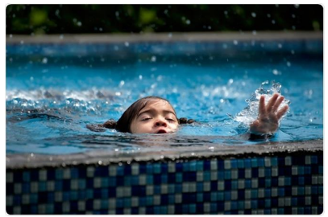

**User is safe:**

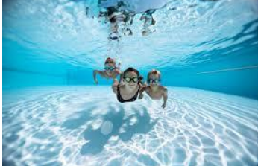

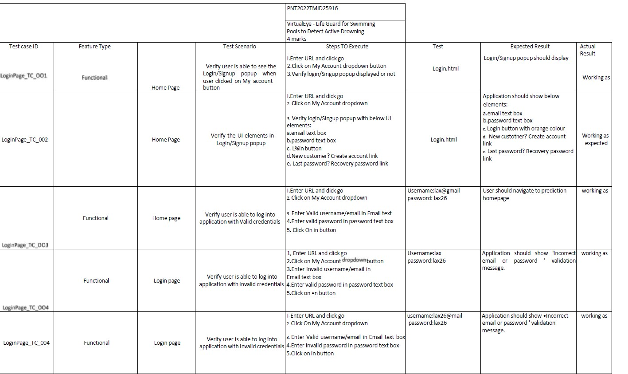

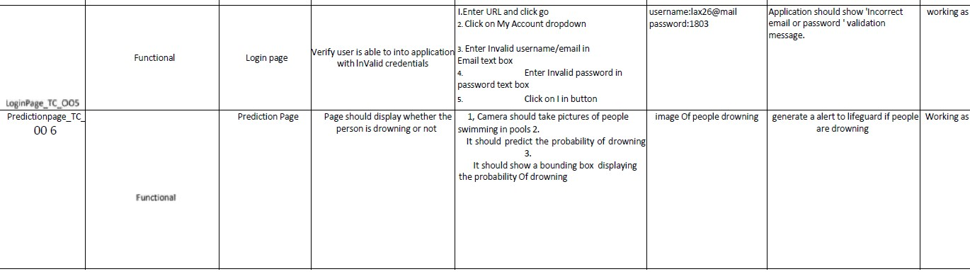

* 1. **User Acceptance Testing:**

**Defect Analysis:**

This report shows the number of resolved or closed bugs at each severity level, and how they were resolved.

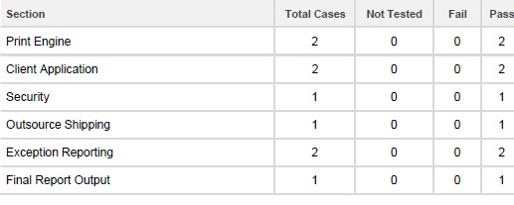

**Test Case Analysis:**

This report shows the number of test cases that have passed, failed, and untested.

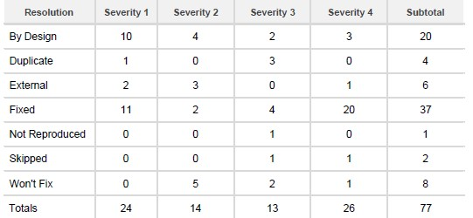

1. **RESULTS:**
   1. **Performance Metrics/Testing:**

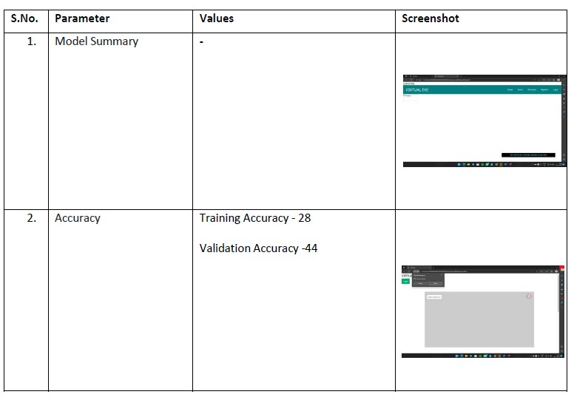

Drowning Detection and Tracking Results The YOLO detection algorithm uses

416X416 as input size. Drowning victims are detected in three stages using a

YOLO-based detection technique. Even if the swimmer stayed underwater for a long

time, the Deep SORT algorithm was able to track him.

Accuracy = (TP + TN) / (TP + TN + FP + FN)

TP - True Positives

FP - False Positives

TN - True Negatives

FN - False Negatives

ACCURACY VARIABLES

COUNT

TP

220

TN

208

FP

42

FN

30

1. **ADVANTAGES AND DISADVANTAGES:**

**ADVANTAGES:**

* Helps in surveillance of young children/beginners of swimming , from drowning risks.
* Blows an alarm too, so it is helpful to rescue the victim swimmer ,instantly.

**DISADVANTAGES:**

* Concerns over inconsistent levels of reliability of systems and situations where glare, swimming aids or high occupancy / activity rates can cause false alarms
* Impact of the additional cost on financial viability
* Limited level of in-use knowledge and experience

1. **CONCLUSION:**

Consistently numerous people, including kids, are suffocated or near suffocating in the deeps of the swimming pools, and the lifeguards are not prepared all around to deal with these issues. In this manner raises the necessities for having a framework that will thus recognize the suffocating people and alert the lifeguards at such hazard. It can be installed in International standardized schools where classes are held for training kids.

1. **FUTURE SCOPE:**

The European Union is encouraging the use of wearable life jackets by increasing distribution and educating and supervising people within the swimming pool environment. The U.K. government is also supporting technological developments that can enhance the role of life suits by adding an additional layer of safety and providing first aid in emergencies.

**Market Highlights:**

The global anti-drowning system market size was valued at USD 67.68 million in 2021. It is projected to reach USD 98.86 million by 2030, growing at a CAGR of 4.3% during the forecast period (2022-2030).

The residential segment by application is estimated to grow at a CAGR of 3.9% during the forecast period. The rising drowning incidents among children in bathtubs, residential swimming pools, and others due to negligence of parents, which can be further attributed to hectic schedules, and the poor construction of bathing/swimming premises in homes have increased the need for effective safety measures in residential pools.

The indirect sales channel is expected to grow at a CAGR of 3.8%, propelled by the increasing number of credit card owners and favorable transaction schemes and discounts that have reduced manufacturers' financial risk.

North America Dominates the Market with More Than Half the Global Value Share.

Some of the key players operating in the market are

* Variopool
* Swim Eye
* Poolview Limited
* Coral Detection System
* Sentag
* SEAL SwimSafe
* Poseidon Technologies
* AngelEye

1. **APPENDIX:**

**Source Code:**

**Login.html**

<!DOCTYPE html>

<html >

<head>

<meta charset="UTF-8">

<meta name="viewport" content="width=device-width, initial- scale=1">

<title>Virtual Eye</title>

<link href='https://fonts.googleapis.com/css?family=Pacifico' rel='stylesheet' type='text/css'>

<link href='https://fonts.googleapis.com/css?family=Arimo' rel='stylesheet' type='text/css'>

<link href='https://fonts.googleapis.com/css?family=Hind:300' rel='stylesheet' type='text/css'>

<link href='https://fonts.googleapis.com/css?family=Open+Sans+Conde nsed:300' rel='stylesheet' type='text/css'>

<!link rel="stylesheet" href="{{ url_for('static', filename='css/style.css') }}">

<link href='https://fonts.googleapis.com/css?family=Merriweather' rel='stylesheet'>

<link href='https://fonts.googleapis.com/css?family=Josefin Sans' rel='stylesheet'>

<link href='https://fonts.googleapis.com/css?family=Montserrat' rel='stylesheet'>

<style>

.header {

}

.topnav {

top:0; margin:0px; left: 0px; right: 0px;

position: fixed;

background-color: #28272c; color: white;

box-shadow: 0px 8px 4px grey; overflow: hidden;

padding-left:20px;

font-family: 'Josefin Sans'; font-size: 2vw;

width: 100%; height:8%;

text-align: center;

overflow: hidden; background-color: #333;

}

.topnav-right a {

float: left; color: #f2f2f2;

text-align: center; padding: 14px 16px; text-decoration: none; font-size: 18px;

}

.topnav-right a:hover { background-color: #ddd; color: black;

}

.topnav-right a.active { background-color: #565961; color: white;

}

.topnav-right { float: right;

padding-right:100px;

}

.login{

margin-top:-70px;

}

body {

background-color:#ffffff; background-repeat: no-repeat; background-size:cover; background-position: 0px 0px;

}

.login{

margin-top:100px;

}

form {border: 3px solid #f1f1f1; margin-left:400px;margin- right:400px;}

input[type=text], input[type=email],input[type=number],input[type=password] { width: 100%;

padding: 12px 20px; display: inline-block; margin-bottom:18px; border: 1px solid #ccc; box-sizing: border-box;

}

button {

background-color: #28272c; color: white;

padding: 14px 20px; margin-bottom:8px; border: none; cursor: pointer; width: 100%;

font-weight:bold;

}

button:hover { opacity: 0.8;

}

.cancelbtn { width: auto;

padding: 10px 18px; background-color: #f44336;

}

.imgcontainer { text-align: center;

margin: 24px 0 12px 0;

}

img.avatar { width: 30%;

border-radius: 50%;

}

.container { padding: 16px;

}

span.psw { float: right;

padding-top: 16px;

}

/* Change styles for span and cancel button on extra small screens

*/

@media screen and (max-width: 300px) { span.psw {

display: block; float: none;

}

.cancelbtn { width: 100%;

}

}

</style>

</head>

<body style="font-family:Montserrat;">

<div class="header">

<div style="width:50%;float:left;font-size:2vw;text- align:left;color:white; padding-top:1%">Virtual Eye</div>

<div class="topnav-right" style="padding-top:0.5%;">

<a href="{{ url_for('index')}}">Home</a>

<a class="active" href="{{ url_for('login')}}">Login</a>

<a href="{{ url_for('register')}}">Register</a>

</div>

</div>

<div id="login" class="login">

<form action="{{url_for('afterlogin')}}" method="post">

<div class="imgcontainer">

<img style="" src="https://cdn.digitalhealth.net/wp- content/uploads/2017/03/eye_image_generic_555.jpg" alt="Avatar" class="avatar">

</div>

<div class="container">

<input type="email" placeholder="Enter registered email ID" name="_id" required><br>

<input type="password" placeholder="Enter Password" name="psw" required>

{{pred}}

<button type="submit">Login</button><br>

</div>

</form>

</div>

</body>

</html>

**Register.html**

<!DOCTYPE html>

<html >

<head>

<meta charset="UTF-8">

<meta name="viewport" content="width=device-width, initial- scale=1">

<title>Virtual Eye</title>

<link href='https://fonts.googleapis.com/css?family=Pacifico' rel='stylesheet' type='text/css'>

<link href='https://fonts.googleapis.com/css?family=Arimo' rel='stylesheet' type='text/css'>

<link href='https://fonts.googleapis.com/css?family=Hind:300' rel='stylesheet' type='text/css'>

<link href='https://fonts.googleapis.com/css?family=Open+Sans+Conde nsed:300' rel='stylesheet' type='text/css'>

<link rel="stylesheet" href="{{ url_for('static', filename='css/style.css') }}">

<link href='https://fonts.googleapis.com/css?family=Merriweather' rel='stylesheet'>

<link href='https://fonts.googleapis.com/css?family=Josefin Sans' rel='stylesheet'>

<link href='https://fonts.googleapis.com/css?family=Montserrat' rel='stylesheet'>

<style>

.header {

}

top:0; margin:0px; left: 0px; right: 0px;

position: fixed;

background-color: #28272c; color: white;

box-shadow: 0px 8px 4px grey; overflow: hidden;

padding-left:20px;

font-family: 'Josefin Sans'; font-size: 2vw;

width: 100%; height:8%;

text-align: center;

.topnav {

overflow: hidden; background-color: #333;

}

.topnav-right a { float: left; color: #f2f2f2;

text-align: center; padding: 14px 16px; text-decoration: none; font-size: 18px;

}

.topnav-right a:hover { background-color: #ddd; color: black;

}

.topnav-right a.active { background-color: #565961; color: white;

}

.topnav-right { float: right;

padding-right:100px;

}

.login{

margin-top:-70px;

}

body {

background-color:#ffffff; background-repeat: no-repeat; background-size:cover; background-position: 0px 0px;

}

.login{

margin-top:100px;

}

form {border: 3px solid #f1f1f1; margin-left:400px;margin- right:400px;}

input[type=text], input[type=email],input[type=number],input[type=password] { width: 100%;

padding: 12px 20px; display: inline-block; margin-bottom:18px; border: 1px solid #ccc; box-sizing: border-box;

}

button {

background-color: #28272c; color: white;

padding: 14px 20px; margin-bottom:8px; border: none; cursor: pointer; width: 100%;

}

button:hover { opacity: 0.8;

}

.cancelbtn { width: auto;

padding: 10px 18px; background-color: #f44336;

}

.imgcontainer { text-align: center;

margin: 24px 0 12px 0;

}

img.avatar { width: 30%;

border-radius: 50%;

}

.container { padding: 16px;

}

span.psw { float: right;

padding-top: 16px;

}

/* Change styles for span and cancel button on extra small screens

*/

@media screen and (max-width: 300px) { span.psw {

display: block;

float: none;

}

.cancelbtn { width: 100%;

}

}

</style>

</head>

<body style="font-family:Montserrat;">

<div class="header">

<div style="width:50%;float:left;font-size:2vw;text- align:left;color:white; padding-top:1%">Virtual Eye</div>

<div class="topnav-right" >

<a href="{{ url_for('home')}}">Home</a>

<a href="{{ url_for('login')}}">Login</a>

<a class="active" href="{{ url_for('register')}}">Register</a>

</div>

</div>

<div id="login" class="login">

<form action="{{url_for('afterreg')}}" method="post">

<div class="imgcontainer">

<img style="" src="https://cdn.digitalhealth.net/wp- content/uploads/2017/03/eye_image_generic_555.jpg" alt="Avatar" class="avatar">

</div>

<div class="container">

<input type="text" placeholder="Enter Name" name="name" required><br>

<input type="email" placeholder="Enter Email ID" name="_id" required><br>

<input type="password" placeholder="Enter Password" name="psw" required>

{{pred}}

<button type="submit">Register</button><br>

</div>

<div class="container" style="background-

color:#f1f1f1">

<div class="psw">Already have an account?&nbsp; &nbsp;<a href="{{ url_for('login') }}">Login</a></div >

</div>

</form>

</div>

</body>

</html>

**Base.html**

<html lang="en">

<head>

<meta charset="UTF-8">

<meta name="viewport" content="width=device-width, initial- scale=1.0">

<meta http-equiv="X-UA-Compatible" content="ie=edge">

<title>High Quality Facial Recognition</title>

<link href="https://cdn.bootcss.com/bootstrap/4.0.0/css/bootstrap.min. css" rel="stylesheet">

<script src="https://cdn.bootcss.com/popper.js/1.12.9/umd/popper.min.j s"></script>

<script src="https://cdn.bootcss.com/jquery/3.3.1/jquery.min.js"></script

>

<script src="https://cdn.bootcss.com/bootstrap/4.0.0/js/bootstrap.min.js "></script>

<link href="{{ url_for('static', filename='css/main.css') }}" rel="stylesheet">

<style>

.bg-dark {

background-color: #42678c!important;

}

#result {

color: #0a1c4ed1;

}

</style>

</head>

<body style="background-color:black";>

<header id="head" class="header">

<section id="navbar">

<h1 class="nav-heading"></i>Virtual Eye</h1>

<div class="nav--items">

<ul>

<li><a href="{{ url_for('index')}}">Home</a></li>

<li><a

href="{{ url_for('logout')}}">Logout</a></li>

<!-- <li><a href="#about">About</a></li>

<li><a href="#services">Services</a></li> -->

</ul>

</div>

</section>

</header>

<div class="container">

<div id="content" style="margin-top:2em">

<div class="container">

<div class="row">

<div class="col-sm-6 bd" >

<h2><em style="color:white;">High Quality Facial Recognition</em></h2>

<br>

<p><h5><i style="color:white;">Emotion Detection Through Facial Feature Recognition</i></h5></p>

<img src="https://130e178e8f8ba617604b- 8aedd782b7d22cfe0d1146da69a52436.ssl.cf1.rackcdn.com/facial- recognition-use-triggers-gdpr-fine-showcase_image-10-a- 12991.jpg" style="height:240px"class="img-rounded" alt="Gesture">

</div>

<div class="col-sm-6">

<div>

<h4 style="color:white;">Upload

Image Here</h4>

<form action = "http://localhost:5000/" id="upload-file" method="post" enctype="multipart/form-data">

<label for="imageUpload" class="upload-

label">

Choose Image

</label>

<input type="file" name="image"

id="imageUpload" accept=".png, .jpg, .jpeg,.pdf">

</form>

<div class="image-section" style="display:none;">

<div class="img-preview">

<div id="imagePreview">

</div>

</div>

<div>

<button type="button" class="btn btn- info btn-lg " id="btn-predict">Analyse</button>

</div>

</div>

<div class="loader" style="display:none;"></div>

<h3>

<span id="result"> </span>

</h3>

</div>

</div>

</div>

</body>

</div>

</div>

</div>

<footer>

<script src="{{ url_for('static', filename='js/main.js') }}" type="text/javascript"></script>

</footer>

</html>

**Index.html**

<!DOCTYPE html>

<html lang="en">

<head>

<meta charset="UTF-8">

<meta http-equiv="X-UA-Compatible" content="IE=edge">

<meta name="viewport" content="width=device-width, initial- scale=1.0">

<!--Bootstrap -->

<link rel="stylesheet" href="https://maxcdn.bootstrapcdn.com/bootstrap/4.0.0/css/boo tstrap.min.css" integrity="sha384- Gn5384xqQ1aoWXA+058RXPxPg6fy4IWvTNh0E263XmFcJlSAwiGg FAW/dAiS6JXm" crossorigin="anonymous">

<script src="https://code.jquery.com/jquery-3.2.1.slim.min.js" integrity="sha384- KJ3o2DKtIkvYIK3UENzmM7KCkRr/rE9/Qpg6aAZGJwFDMVNA/GpG FF93hXpG5KkN" crossorigin="anonymous"></script>

<script src="https://cdnjs.cloudflare.com/ajax/libs/popper.js/1.12.9/umd/ popper.min.js" integrity="sha384- ApNbgh9B+Y1QKtv3Rn7W3mgPxhU9K/ScQsAP7hUibX39j7fakFPsk vXusvfa0b4Q" crossorigin="anonymous"></script>

<script src="https://maxcdn.bootstrapcdn.com/bootstrap/4.0.0/js/bootst rap.min.js" integrity="sha384- JZR6Spejh4U02d8jOt6vLEHfe/JQGiRRSQQxSfFWpi1MquVdAyjUar5

+76PVCmYl" crossorigin="anonymous"></script>

<script src="https://kit.fontawesome.com/8b9cdc2059.js" crossorigin="anonymous"></script>

<link href="https://fonts.googleapis.com/css2?family=Akronim&family= Roboto&display=swap" rel="stylesheet">

<link rel="stylesheet" href="../static/style.css">

<!-- <script defer src="../static/js/main.js"></script> -->

<title>Virtual Eye</title>

</head>

<body>

<header id="head" class="header">

<section id="navbar">

<h1 class="nav-heading"></i>Virtual Eye</h1>

<div class="nav--items">

<ul>

<li><a

href="{{ url_for('index')}}">Home</a></li>

<li><a

href="{{ url_for('login')}}">Login</a></li>

<li><a

href="{{ url_for('register')}}">Register</a></li>

<li><a href="{{ url_for('login')}}">Demo</a></li>

</ul>

</div>

</section>

<section id="slider">

<div id="carouselExampleIndicators" class="carousel" data- ride="carousel">

<ol class="carousel-indicators ">

<li data-target="#carouselExampleIndicators" data-slide- to="0" class="active "></li>

<li data-target="#carouselExampleIndicators" data-slide- to="1"></li>

<li data-target="#carouselExampleIndicators" data-slide- to="2"></li>

</ol>

<div class="carousel-inner">

<div class="carousel-item active">

<img class="d-block w-100" src="../static/img/1.png" alt="First slide">

</div>

<div class="carousel-item">

<img class="d-block w-100" src="../static/img/second.jpg" alt="Second slide">

</div>

<div class="carousel-item">

<img class="d-block w-100" src="../static/img/third.jpg" alt="Third slide">

</div>

</div>

<a class="carousel-control-prev" href="#carouselExampleIndicators" role="button" data- slide="prev">

<span class="carousel-control-prev-icon" aria- hidden="true"></span>

<span class="sr-only">Previous</span>

</a>

<a class="carousel-control-next" href="#carouselExampleIndicators" role="button" data- slide="next">

<span class="carousel-control-next-icon" aria- hidden="true"></span>

<span class="sr-only">Next</span>

</a>

</div>

</section>

</header>

<section id="about">

<div class="top">

<h3 class="title text-muted"> ABOUT PROJECT

</h3>

<div class="line"></div>

</div>

<div class="body">

<div class="left">

<h2>Problem:</h2>

<p>

</p>

</div>

<div class="left">

<h2>Solution:</h2>

<p>

</p>

</div>

</div>

<div class="bottom">

<p ><b>

</b></p>

</div>

</section>

<section id="footer">

<div class="social">

<a href="#" target="_blank"><i class="fab fa-2x fa-twitter- square"></i></a>

<a href="#" target="_blank">

<i class="fab fa-2x fa-linkedin"></i></a>

<a href="#">

<i class="#"></i>

</a>

</div>

</section>

</body>

</html>

Logout.html

<!DOCTYPE html>

<html >

<head>

<meta charset="UTF-8">

<meta name="viewport" content="width=device-width, initial- scale=1">

<title>Virtual Eye</title>

<link href='https://fonts.googleapis.com/css?family=Pacifico' rel='stylesheet' type='text/css'>

<link href='https://fonts.googleapis.com/css?family=Arimo' rel='stylesheet' type='text/css'>

<link href='https://fonts.googleapis.com/css?family=Hind:300' rel='stylesheet' type='text/css'>

<link href='https://fonts.googleapis.com/css?family=Open+Sans+Conde nsed:300' rel='stylesheet' type='text/css'>

<link href='https://fonts.googleapis.com/css?family=Merriweather' rel='stylesheet'>

<link href='https://fonts.googleapis.com/css?family=Josefin Sans' rel='stylesheet'>

<link href='https://fonts.googleapis.com/css?family=Montserrat' rel='stylesheet'>

<style>

.header {

top:0; margin:0px;

left: 0px; right: 0px;

position: fixed;

background-color: #28272c; color: white;

box-shadow: 0px 8px 4px grey; overflow: hidden;

padding-left:20px;

font-family: 'Josefin Sans'; font-size: 2vw;

width: 100%; height:8%;

text-align: center;

}

.topnav { overflow: hidden; background-color: #333;

}

.topnav-right a { float: left; color: #f2f2f2;

text-align: center; padding: 14px 16px; text-decoration: none; font-size: 18px;

}

.topnav-right a:hover { background-color: #ddd; color: black;

}

.topnav-right a.active { background-color: #565961; color: white;

}

.topnav-right { float: right;

padding-right:100px;

}

.login{

margin-top:-70px;

}

body {

background-color:#ffffff; background-repeat: no-repeat; background-size:cover; background-position: 0px 0px;

}

.main{

margin-top:100px; text-align:center;

}

form { margin-left:400px;margin-right:400px;}

input[type=text], input[type=email],input[type=number],input[type=password] { width: 100%;

padding: 12px 20px; display: inline-block; margin-bottom:18px; border: 1px solid #ccc;

box-sizing: border-box;

}

button {

background-color: #28272c; color: white;

padding: 14px 20px; margin-bottom:8px; border: none; cursor: pointer; width: 20%;

}

button:hover { opacity: 0.8;

}

.cancelbtn { width: auto;

padding: 10px 18px; background-color: #f44336;

}

.imgcontainer { text-align: center;

margin: 24px 0 12px 0;

}

img.avatar { width: 30%;

border-radius: 50%;

}

.container { padding: 16px;

}

span.psw { float: right;

padding-top: 16px;

}

/* Change styles for span and cancel button on extra small screens

*/

@media screen and (max-width: 300px) { span.psw {

display: block; float: none;

}

.cancelbtn { width: 100%;

}

}

</style>

</head>

<body style="font-family:Montserrat;">

<div class="header">

<div style="width:50%;float:left;font-size:2vw;text- align:left;color:white; padding-top:1%">Virtual eye</div>

<div class="topnav-right" style="padding-top:0.5%;">

<a href="{{ url_for('home')}}">Home</a>

<a href="{{ url_for('login')}}">Login</a>

<a href="{{ url_for('register')}}">Register</a>

</div>

</div>

<div class="main">

<h1>Successfully Logged Out!</h1>

<h3 style="color:#4CAF50">Login for more information<h3>

<a href="{{ url_for('login') }}"><button type="submit">Login</button></a>

</form>

</div>

</body>

</html>

Prediction.html

<!DOCTYPE html>

<html lang="en">

<head>

<meta charset="UTF-8">

<meta http-equiv="X-UA-Compatible" content="IE=edge">

<meta name="viewport" content="width=device-width, initial- scale=1.0">

<!--Bootstrap -->

<link rel="stylesheet" href="https://maxcdn.bootstrapcdn.com/bootstrap/4.0.0/css/boo tstrap.min.css" integrity="sha384- Gn5384xqQ1aoWXA+058RXPxPg6fy4IWvTNh0E263XmFcJlSAwiGg FAW/dAiS6JXm" crossorigin="anonymous">

<script src="https://code.jquery.com/jquery-3.2.1.slim.min.js" integrity="sha384-

KJ3o2DKtIkvYIK3UENzmM7KCkRr/rE9/Qpg6aAZGJwFDMVNA/GpG FF93hXpG5KkN" crossorigin="anonymous"></script>

<script src="https://cdnjs.cloudflare.com/ajax/libs/popper.js/1.12.9/umd/ popper.min.js" integrity="sha384- ApNbgh9B+Y1QKtv3Rn7W3mgPxhU9K/ScQsAP7hUibX39j7fakFPsk vXusvfa0b4Q" crossorigin="anonymous"></script>

<script src="https://maxcdn.bootstrapcdn.com/bootstrap/4.0.0/js/bootst rap.min.js" integrity="sha384- JZR6Spejh4U02d8jOt6vLEHfe/JQGiRRSQQxSfFWpi1MquVdAyjUar5

+76PVCmYl" crossorigin="anonymous"></script>

<script src="https://kit.fontawesome.com/8b9cdc2059.js" crossorigin="anonymous"></script>

<link href="https://fonts.googleapis.com/css2?family=Akronim&family= Roboto&display=swap" rel="stylesheet">

<link rel="stylesheet" href="../static/style.css">

<script defer src="../static/js/JScript.js"></script>

<title>Prediction</title>

</head>

<body>

<header id="head" class="header">

<section id="navbar">

<h1 class="nav-heading"></i>Virtual Eye</h1>

<div class="nav--items">

<ul>

<li><a href="{{ url_for('index')}}">Home</a></li>

<li><a

href="{{ url_for('logout')}}">Logout</a></li>

<!-- <li><a href="#about">About</a></li>

<li><a href="#services">Services</a></li> -->

</ul>

</div>

</section>

</header>

<!-- dataset/Training/metal/metal326.jpg -->

</br>

<section id="prediction">

<h2 class="title text-muted">Virtual Eye- Life Guard for Swimming Pools to Detect Active Drowning</h1>

<div class="line" style="width: 900px;"></div>

</section>

</br>

<section id="about">

<div class="body">

<div class="left">

<p>

</p>

</div>

<div class="left">

<div class="prediction-input">

<img class="d-block w-100" src="../static/img/second.jpg" alt="Second slide">

</br>

<form id="form" action="/result" method="post" enctype="multipart/form-data">

<input type="submit" class="submitbtn" value="Click Me! For a Demo">

</form>

</div>

<h5 style="text-color:Red">

<b style="text-color:Red">{{prediction}}<b>

</h5>

</div>

</div>

</section>

</br></br>

<section id="footer">

</section>

</body>

</html>

**App.py:**

import re

import numpy as np import os

from flask import Flask, app, request, render_template, redirect, url_for from tensorflow.keras import models

from tensorflow.keras.models import load_model from tensorflow.keras.preprocessing import image

from tensorflow.python.ops.gen_array_ops import concat import cvlib as cv

from cvlib.object_detection import draw_bbox import cv2

import time

from playsound import playsound import requests

#Loading the model

from cloudant.client import Cloudant # Authenticate using an IAM API key

client = Cloudant.iam('57f444d5-dfbd-4fc0-b752-dea54005c3cc- bluemix','HTLp9_GkWGDyMR9VHruMMwi_qzZ43qaI3UVR77GOI2GX', connect=True)

# Create a database using an initialized client my_database = client.create_database('my_database')

app=Flask( name )

#default home page or route @app.route('/')

def index():

return render_template('index.html')

@app.route('/index.html') def home():

return render_template("index.html")

#registration page @app.route('/register') def register():

return render_template('register.html')

@app.route('/afterreg', methods=['POST']) def afterreg():

x = [x for x in request.form.values()] print(x)

data = {

'_id': x[1], # Setting _id is optional 'name': x[0],

'psw':x[2]

}

print(data)

query = {'_id': {'$eq': data['_id']}}

docs = my_database.get_query_result(query) print(docs)

print(len(docs.all()))

if(len(docs.all())==0):

url = my_database.create_document(data) #response = requests.get(url)

return render_template('register.html', pred="Registration Successful, please login using your details")

else:

return render_template('register.html', pred="You are already a member, please login using your details")

#login page @app.route('/login') def login():

return render_template('login.html')

@app.route('/afterlogin',methods=['POST']) def afterlogin():

user = request.form['_id'] passw = request.form['psw'] print(user,passw)

query = {'_id': {'$eq': user}}

docs = my_database.get_query_result(query) print(docs)

print(len(docs.all()))

if(len(docs.all())==0):

return render_template('login.html', pred="The username is not found.") else:

if((user==docs[0][0]['_id'] and passw==docs[0][0]['psw'])): return redirect(url_for('prediction'))

else:

print('Invalid User')

@app.route('/logout') def logout():

return render_template('logout.html')

@app.route('/prediction') def prediction():

return render_template('prediction.html')

@app.route('/result',methods=["GET","POST"]) def res():

webcam = cv2.VideoCapture('drowning.mp4')

if not webcam.isOpened(): print("Could not open webcam") exit()

t0 = time.time() #gives time in seconds after 1970

#variable dcount stands for how many seconds the person has been standing still for

centre0 = np.zeros(2) isDrowning = False

#this loop happens approximately every 1 second, so if a person doesn't move, #or moves very little for 10seconds, we can say they are drowning

#loop through frames while webcam.isOpened():

# read frame from webcam status, frame = webcam.read() #print(frame)

if not status:

print("Could not read frame") exit()

# apply object detection

bbox, label, conf = cv.detect_common_objects(frame)

#simplifying for only 1 person #print('bbox',bbox) #print('label',label) #print('conf',conf)

#s = (len(bbox), 2)

if(len(bbox)>0): bbox0 = bbox[0]

#centre = np.zeros(s) centre = [0,0]

#for i in range(0, len(bbox)):

#centre[i] =[(bbox[i][0]+bbox[i][2])/2,(bbox[i][1]+bbox[i][3])/2 ] centre =[(bbox0[0]+bbox0[2])/2,(bbox0[1]+bbox0[3])/2 ]

#make vertical and horizontal movement variables hmov = abs(centre[0]-centre0[0])

vmov = abs(centre[1]-centre0[1])

#there is still need to tweek the threshold

#this threshold is for checking how much the centre has moved x=time.time()

threshold = 10

if(hmov>threshold or vmov>threshold): print(x-t0, 's')

t0 = time.time() isDrowning = False

else:

print(x-t0, 's') if((time.time() - t0) > 10):

isDrowning = True

#print('bounding box: ', bbox, 'label: ' label ,'confidence: ' conf[0], 'centre: ', centre)

#print(bbox,label ,conf, centre)

print('bbox: ', bbox, 'centre:', centre, 'centre0:', centre0) print('Is he drowning: ', isDrowning)

centre0 = centre

# draw bounding box over detected objects #print('came here')

out = draw_bbox(frame, bbox, label, conf,colors=None,write_conf=isDrowning) #print('Seconds since last epoch: ', time.time()-t0)

# display output

cv2.imshow("Real-time object detection", out) if(isDrowning == True):

playsound('alarm.mp3') webcam.release() cv2.destroyAllWindows()

#return render_template('prediction.html',prediction="Emergency !!! The Person is drowining")

#return render_template('base.html')

# press "Q" to stop

if cv2.waitKey(1) & 0xFF == ord('q'): break

# release resources webcam.release() cv2.destroyAllWindows()

return render_template('prediction.html',prediction="Emergency !!! The Person is drowining")

""" Running our application """ if name == " main ":

app.run(debug=False)

**GitHub & Project Demo Link:**

Click here for >> [**GITHUB REPO**](https://github.com/IBM-EPBL/IBM-Project-4130-1658720263)

Click here for >>[**PROJECT DEMO**](https://drive.google.com/uc?export=view&id=1Ay1jxRwck1RsPmlCMMImwHwbnZYvudb0)